Instructions to Setup and Use Wi-Fi Direct for
Data Transfer from Raspberry Pi to Dashboard

Overview
This document provides step-by-step instructions to setup and use Wi-Fi Direct on the Raspberry Pi Zero to transfer sensor data that was recorded on the Raspberry Pi to your PC using the IPR Dashboard software.

Platform Requirements:
- Hardware: Raspberry Pi Zero 2W
- Operating System: Raspberry Pi OS (64-bit recommended)
- Software: IPR Dashboard software v2.0 or greater
- PC Software: Putty SSH (or any other built-in Windows 10+, macOS, Linux tools)
- Optional: WinSCP (Windows) or similar SFTP client for file management

Estimated Time
- Initial Setup: 45-60 minutes
- Testing and Verification: 15 minutes
- Total: ~75 minutes

This document covers the following setup instructions:
- Preparing the Raspberry Pi
- Enabling Wi-Fi Direct (P2P) on Raspberry Pi and auto-start
- Setting up the Python logging script
- Start the Python Logger Automatically on Boot
- Accessing the Raspberry Pi from your IPR Dashboard software

____________________________________________________________________________

Setup Instructions:

- Preparing the Raspberry Pi (20 minutes)
  - Install Raspberry Pi OS
    - Download the Raspberry Pi Imager from: https://www.raspberrypi.com/software/operating-systems/
    - Launch the Imager and configure:
- Device: Select "Raspberry Pi Zero 2 W"
- OS: Select "Raspberry Pi OS (64-bit)" or "Raspberry Pi OS Lite (64-bit)" if you don't need a desktop interface
- Storage: Select your microSD card
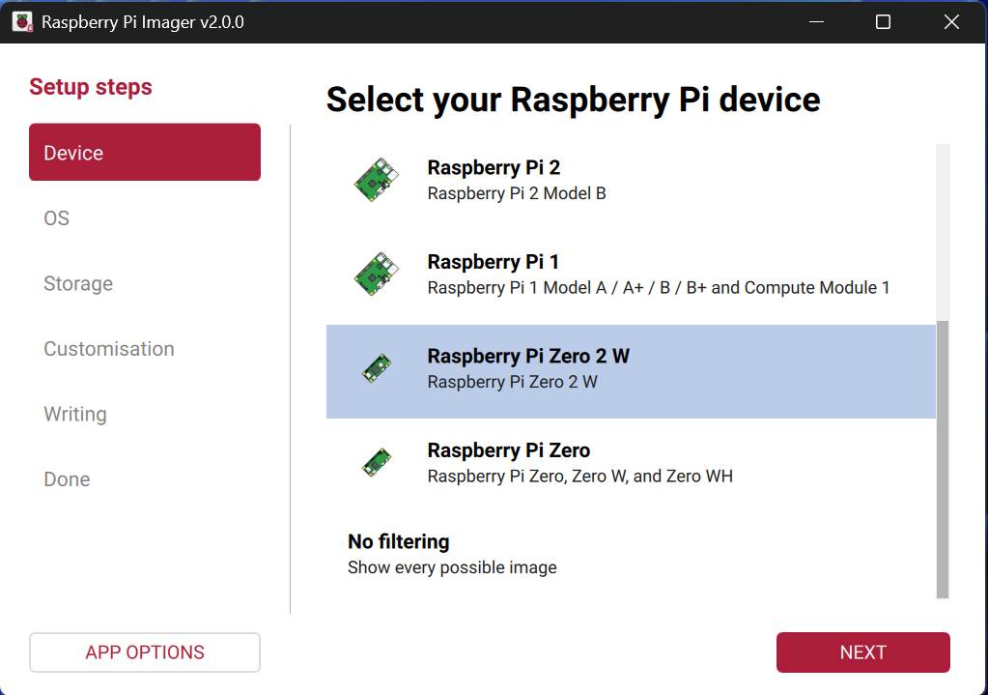
Select Raspberry Pi Zero 2 W from the list

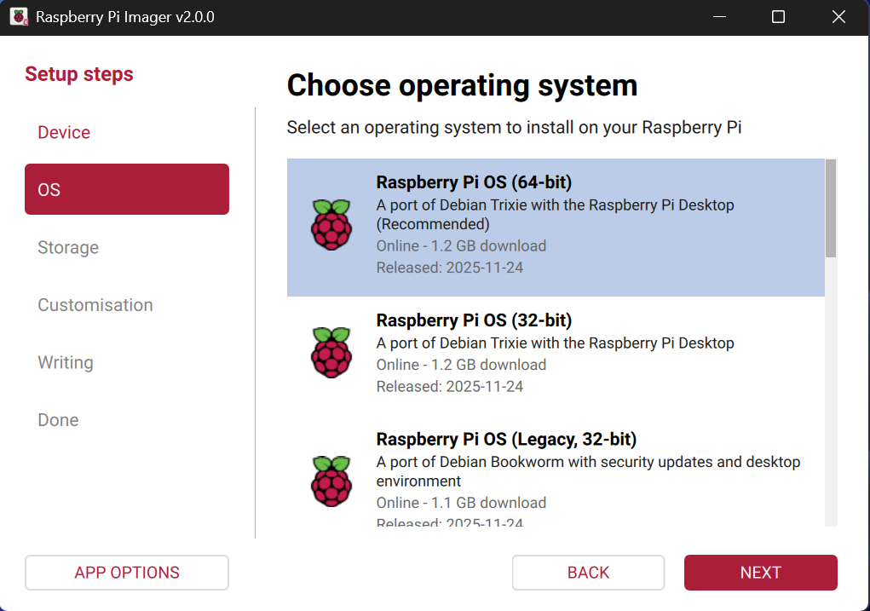
Select the Raspberry Pi OS, it can be the Lite version if no desktop is needed

    - Click the Settings gear icon (or press Ctrl+Shift+X) to configure OS customization

  - Configure OS Settings (IMPORTANT)

Configure the following settings in the Imager:
Hostname:
- Set to: “IPR-sensor”
- This allows you to access the Pi at “IPR-sensor.local” on the same Wi-Fi network

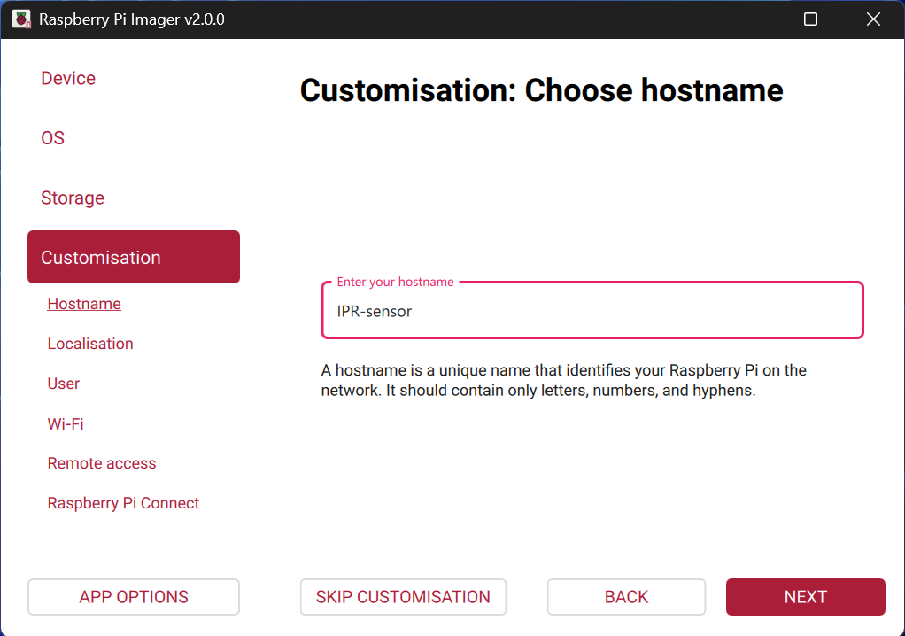
Create a device hostname

Username and Password (REQUIRED):
- Username: “ipr-sensor”
- Password: “ipr-sensor”
- Note: These credentials will be used for SSH access throughout this guide

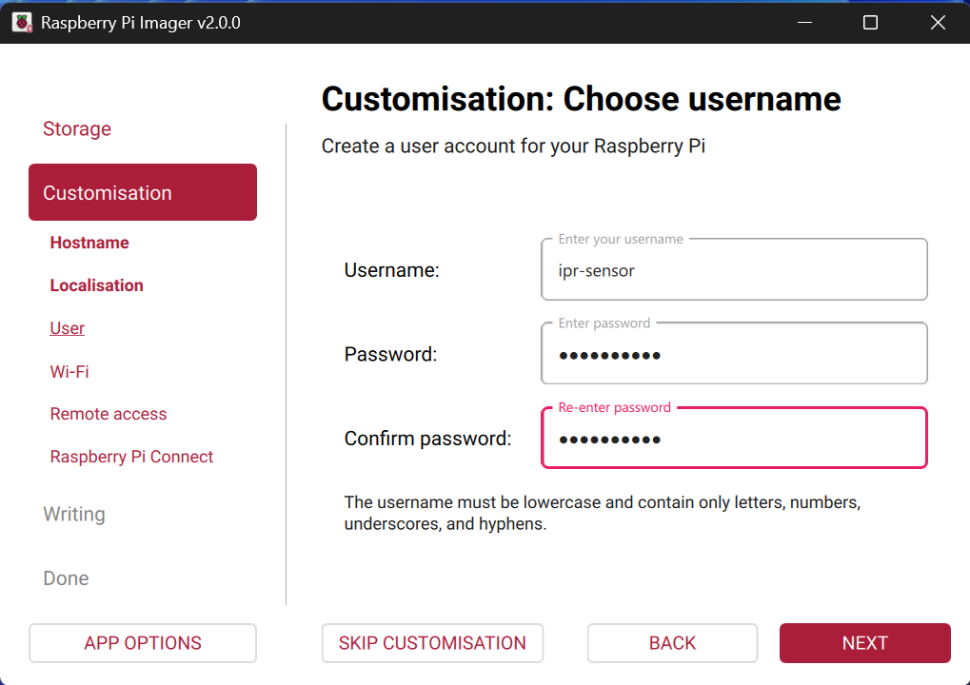
Setup the username and password for the main user. This will be used for the SSH communication later

Enable SSH (REQUIRED):
- Enable "Use password authentication"

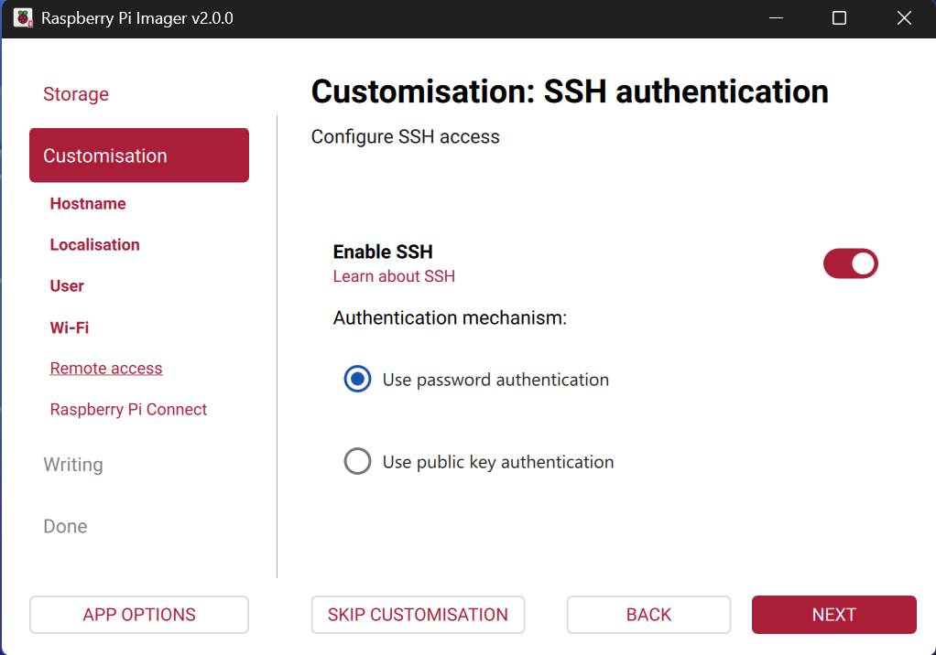
Enable SSH communication with the Raspberry Pi

Wi-Fi Configuration (TEMPORARY - Optional):
- Configure your local Wi-Fi network credentials
- This is only needed if you don't have a monitor/keyboard for the Pi
- Note: This Wi-Fi connection will be replaced by Wi-Fi Direct in Step 2

Locale Settings:
- Set your timezone and keyboard layout

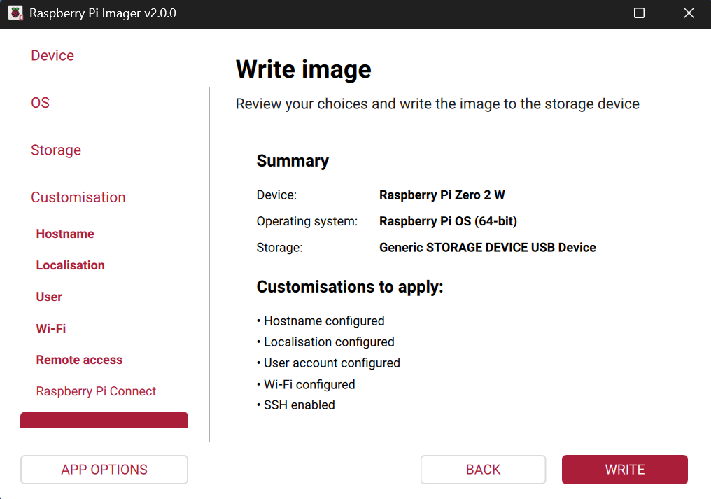
Summary of the installation

  - Click Save, then click Write to flash the OS to the SD card
  - Once complete, safely eject the SD card
  - Initial Boot and System Update
    - Insert the SD card into your Raspberry Pi and power it on
    - Wait 2-3 minutes for the first boot to complete
    - Connect to the Pi via SSH:
- If you configured Wi-Fi: “ssh ipr-sensor@ipr-sensor.local” or use the Pi's IP address with the port 22
- If using direct connection: Connect monitor and keyboard
    - Update the system:
sudo apt update && sudo apt upgrade -y

5. Install required packages:
sudo apt install python3 python3-pip python3-venv git -y

6. Reboot to ensure all updates take effect:
sudo reboot

- Enabling Wi-Fi Direct (P2P) on Raspberry Pi (15 minutes)
Wi-Fi Direct will turn your Raspberry Pi into a Wi-Fi access point, allowing direct connection without a router.

  - Create the Wi-Fi Hotspot
    - SSH into the Raspberry Pi (if not already connected)
    - Run the following command to create a Wi-Fi hotspot:
# Create a hotspot
sudo nmcli device wifi hotspot ssid "PiDirect" password "ipr-sensor"

Configuration Notes:
- SSID: “PiDirect” (you can change this to any name you prefer)
- Password: “ipr-sensor” (you can change this to any password)
- Pi IP Address: The Raspberry Pi will always be accessible at 10.42.0.1

IMPORTANT: Your current SSH session will disconnect because the Pi is no longer connected to your router

  - Connect to the Wi-Fi Direct Network
    - On your PC, scan for Wi-Fi networks
    - Look for the network named “PiDirect” (or the SSID you chose)
    - Connect using the password “ipr-sensor” (or your chosen password)
    - Once connected, you'll be on a direct network with the Pi
Note: You will NOT have internet access while connected to the Pi's hotspot
The Pi will always be at IP address: 10.42.0.1
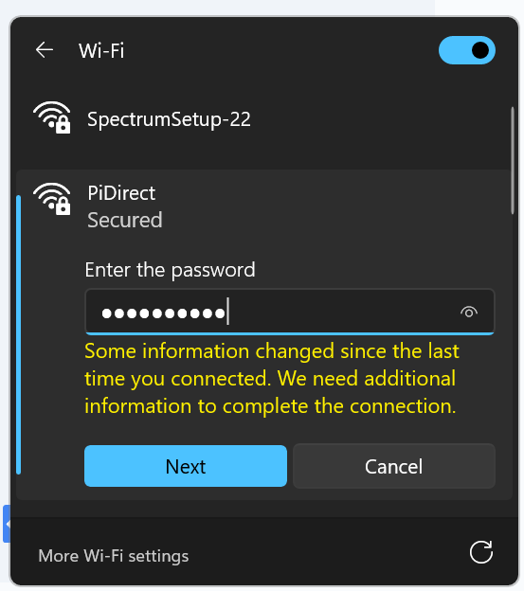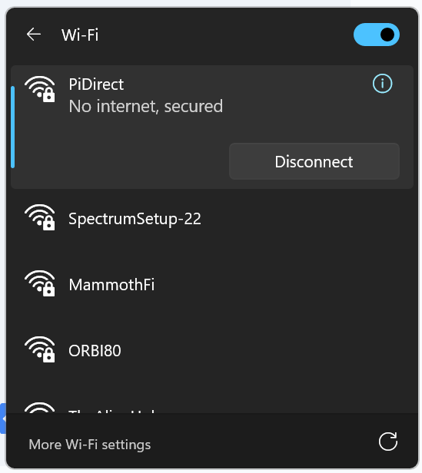

  - Configure Auto-Start on Boot
    - Establish a new SSH connection to the Pi:
ssh IPR-sensor@10.42.0.1

    - Configure the hotspot to start automatically on boot:
# Set auto-connect
sudo nmcli connection modify Hotspot connection.autoconnect yes
# Set priority to ensure it starts
sudo nmcli connection modify Hotspot connection.autoconnect-priority 10

# To check the status if active
nmcli connection show --active

Expected Output: You should see "Hotspot" listed as an active connection

    - Test the configuration by rebooting:
sudo reboot

    - Wait 1-2 minutes, then verify:
- The “PiDirect” network appears in your Wi-Fi list
- You can reconnect and SSH to 10.42.0.1

- Setting up the Python Logging Script (15 minutes)
  - Connect to the Raspberry Pi
  - Install WinSCP on the remote Windows PC (recommended)
https://winscp.net/eng/download.php
  - Connect to the Wi-Fi Direct and login with the user
Host name: 10.42.0.1
Port: 22
Set username and password as defined in step 1.2
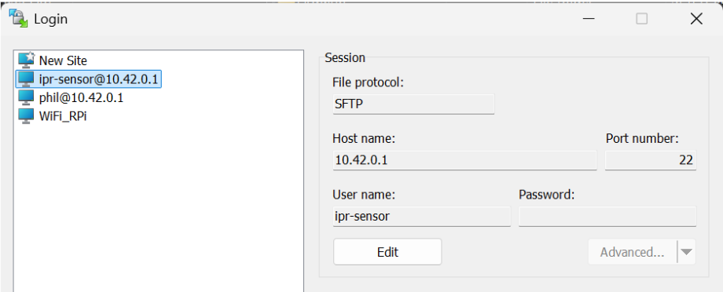

  - Get the latest Python script from GitHub:
https://github.com/phil-engineering/IPR_Wireless_Data_Logger.git

  - Copy all the Python scripts to the Raspberry Pi at the following location:
/home/ipr-sensor/Documents/*

  - Test the script
    - Make sure the sensor is connected to the Raspberry Pi, and powered ON. Then, run the following commands to launch the script.

# Go to the folder where the python script is located
cd Documents
# Run the Python script
python ipr_sensor.py

Make sure it logs sensor data correctly. This will start the recording locally on the RPi with a new BIN file for each 150 MB of data.
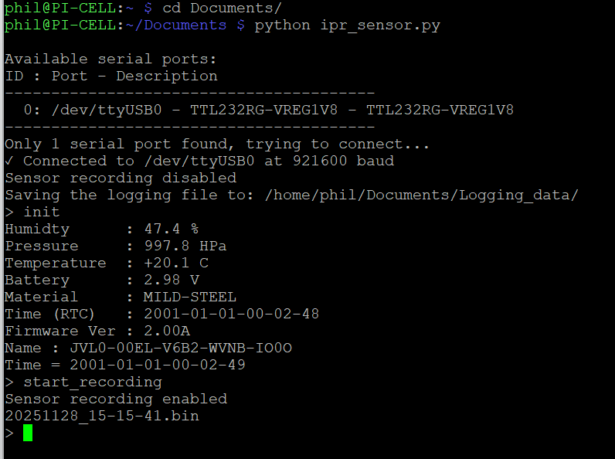
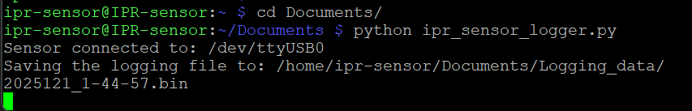

- Accessing the Raspberry Pi from Your IPR Dashboard Software
  - The sensor data file (*.bin) can be copied to the remote PC with WinSCP.
    - Connect to the Raspberry Pi using WinSCP (see Step 3.3)
    - Navigate to “/home/ipr-sensor/Documents/”
    - Copy “*.bin” files to your local PC

  - To view the data, select “Data->Load from local file…” and choose the *.bin file that was saved in step 5.1
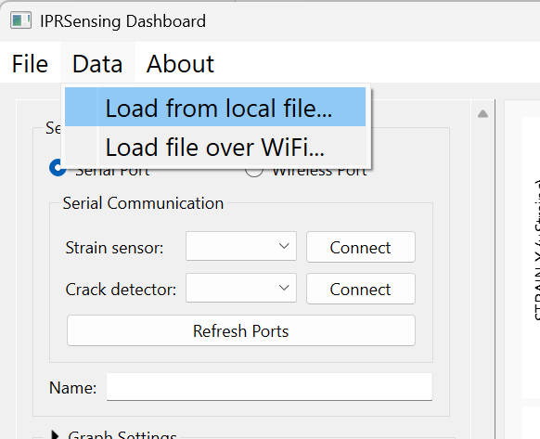

Troubleshooting

Wi-Fi Direct Issues
Problem: Can't see the “PiDirect” network
- Solution: Wait 2-3 minutes after boot for the hotspot to start
- Solution: Check if the service is running: “systemctl status NetworkManager”
- Solution: Manually restart the hotspot: “sudo nmcli connection up Hotspot”

Problem: Can connect to Wi-Fi but can't SSH
- Solution: Verify the Pi's IP is “10.42.0.1”
- Solution: Check SSH service: “sudo systemctl status ssh”
- Solution: Try pinging the Pi first: “ping 10.42.0.1”

Python Logger Issues
Problem: No “.bin” files are created
- Solution: Check sensor connections
- Solution: Verify sensor is powered on
- Solution: Check script has write permissions: “ls -la ~/Documents/”

General Issues
Problem: Lost connection to the Pi
- Solution: Reconnect to the “PiDirect” Wi-Fi network
- Solution: Reboot the Pi and wait 2-3 minutes
- Solution: Check if your PC's Wi-Fi is enabled

Quick Reference

SSH Connection:
ssh IPR-sensor@10.42.0.1

Default Credentials:
- Username: “ipr-sensor”
- Password: “ipr-sensor”
- Raspberry Pi IP Address: “10.42.0.1”
- Wi-Fi SSID: “PiDirect”
- Wi-Fi Password: “ipr-sensor”

